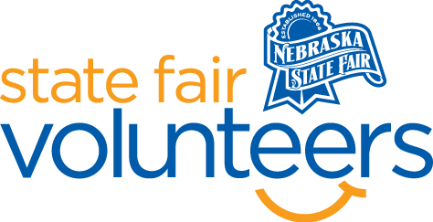

**NSF Volunteer Information Sheet**

***Thank you for offering your time and efforts for the Nebraska State Fair! Your time is very valuable to us, and we appreciate everything that you have to offer to make the Nebraska State Fair a success.***

**Volunteer Position: Raising Nebraska Host - Combine**

**Date/s: All Days**

**Excluding August 23 from 10am-2pm**

**Excluding August 25 from 2pm-6pm Shift/Time Needed: 10am-2pm & 2pm-6pm**

**Number of Volunteer/s Needed: 1**

• **Check-In:**

* Your yellow name badge will be your gate admission into the fair. It is to only be used on days that you are volunteering.
* All volunteers are required to check-in with the volunteer coordinator at Volunteer Headquarters (VHQ) in the Pinnacle Expo Building prior to their shift.
* VHQ assistants will check you in and answer any questions you have before your shift begins.
* Please check in 15 minutes prior to the start of your shift.

• **Location:**

* + Will be positioned in the Nebraska Building in the Raising Nebraska space next to the combine simulator.

• **Responsibilities:**

* Assist fairgoers with the purpose of the "Drive a Combine" to ensure the fairgoer is getting the most out of their experience. This may include reminding children to take turns in using the experience. Help fairgoers with kitchen presentation schedule by letting them know when cooking/food demonstrations will be happening in the kitchen. We may also have last minute cancellations that fairgoers may need to know about as well.
* Be familiar with the Raising Nebraska space and all the areas available for guests to see.
* Welcome and interact with the fairgoers who enter Raising Nebraska in a happy and positive manner.
* BE READY TO GET THE SAME QUESTION OFTEN. Be available for other questions about the Fair and to have other related discussions the person may be interested in having with you.
* HAVE FUN
* Inform Raising Nebraska staff if you have questions you cannot answer or if there is an exhibit that is not working correctly.

• **Requirements:**

* Indoors or Outdoors: Indoors air-conditioned building
* Lifting Requirements: Possible light lifting moving chairs and tables around

• **Check-Out:**

* Volunteers do not need to check out at VHQ as the new system will automatically check you out.
* Raising Nebraska will provide you with a clipboard to use during your shift with a schedule of the activities happening at Raising Nebraska that day. This clipboard should be passed on to the next volunteer at the end of your shift or returned to Raising Nebraska staff.