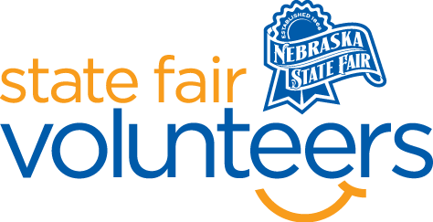
NSF Volunteer Information Sheet

Thank you for offering your time and efforts for the Nebraska State Fair! Your time is very valuable to us, and we appreciate everything that you have to offer to make the Nebraska State Fair a success.

Volunteer Position: Veterans Day Program Volunteer

• Check-In:
- Your yellow name badge will be your gate admission into the fair. It is to only be used on days that you are volunteering.
- All volunteers are required to check-in with the volunteer coordinator at Volunteer Headquarters (VHQ) in the Pinnacle Expo Building prior to their shift.
- VHQ assistants will check you in and share the location of where your shift begins.

• Location:
- Heartland Events Center
• Responsibilities:
  - You will be positioned at the entrance to the floor seating.
  - Usher veterans and other attendees to their seats when assistance is needed (ex: wheelchairs).
  - Greet and welcome guests to the program. Thank veterans for their service.
  - Give directions when asked for assistance.
  - Assist attendees in and out of the elevator.
• Requirements:
- Indoors or Outdoors: Indoors, standing.
- Lifting Requirements: There are no lifting requirements.

• Check-Out:
- Volunteers do not need to check out at VHQ as the new system will automatically check you out.

