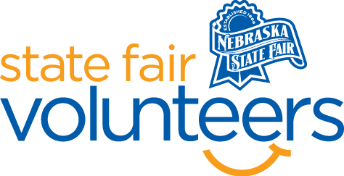
NSF Volunteer Information Sheet

Thank you for offering your time and efforts for the Nebraska State Fair! Your time is very valuable to us, and we appreciate everything that you have to offer to make the Nebraska State Fair a success.

Volunteer Position: Vacuum Fonner Park Club House

• Check-In:
- You will check in with Tina Thuernagle, Director of Operations, at the cleaning office.
- Cleaning office is in the Fonner Park Admen Building in the Jockey’s room.

• Location: Fonner Park Club House

• Responsibilities: You will use a State Fair Vacuum to vacuum the clubhouse after the largest classroom. There will be some tables and chairs that will need to be moved as vacuuming. Maximum weight is 10 pounds. Directions and examples with be provided.

Date needed:
- August 23, 2024, 1:30PM -3:30PM
- August 27, 2024, 1:30PM -3:30PM
- August 28, 2024, 1:30PM -3:30PM

• Requirements:
- Indoors.
- Moving around some tables and chairs.
- The maximum weight on tables and chairs is 10 pounds.

• Check-Out:
- Volunteers do need to check out at Nebraska State Fair Cleaning office.

