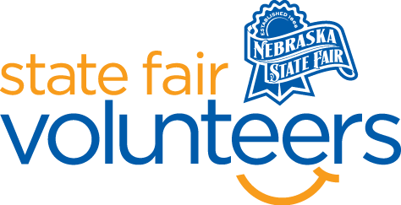
NSF Volunteer Information Sheet

Thank you for offering your time and efforts for the Nebraska State Fair! Your time is very valuable to us, and we appreciate everything that you have to offer to make the Nebraska State Fair a success.

Volunteer Position: Tram Host Volunteer

• Check-In:
- Your yellow name badge will be your gate admission into the fair. It is to only be used on days that you are volunteering.
- All volunteers are required to check-in with the volunteer coordinator at Volunteer Headquarters (VHQ) in the Pinnacle Expo Building prior to their shift.
- VHQ assistants will check you in and share the location of where your shift begins.

• Location: Throughout the fairgrounds
- Pickup will be at one of the many orange “Tram Stop” signs in front of the barns.

• Responsibilities:
- Do Your Homework. Be familiar with the State Fair gate book: daily schedules, general fair information, and the grounds map (before your shift).
- Be Prepared to Get the Same Question Often. Deliver your answer as if it is the first time you heard the question and with a helpful smile every time.
- Be Familiar with the State Fair Grounds Map (and campus landmarks) to help direct Guests to their destination.
  - Remain Calm, Positive, and Helpful. Unfortunately, some Guests may see you as an outlet for complaints. Help the Guest whenever you can and direct them to a more appropriate outlet when you cannot be of assistance. State Fair Administration Office is often the necessary destination. The Administration Office is located in the Nebraska Building and at (308) 382-1620. Know how to direct complaints to this Office.
  - Greet Guests in a Happy and Positive Manner. Smile, offer a warm welcome and thanks for coming.
Parking Lot Trams
  - Remind Guests to Take Note of Where They Parked. Right away, before the tram moves away from a pick up, tell the Guests to take note of where they parked. Help them by identifying a permanent landmark or parking lot location sign. (Remind them to NOT use other vehicles as markers. As those vehicles may move by the time they come out of the fair).
  - Highlight the Current Day’s Activities. Share suggestions with folks about attractions and events that are occurring that day.
  - Note: Will Call and Read & Win Prize Packets are available at ALL GATES
  - Point departing Guests in the direction of the Gates. (the Fair accepts cash, Visa, and MasterCard as payment for gate admission).
  - Be familiar with the day’s gate admission prices (check daily sheet and/or gate signs when you are headed to your starting position.
  - Gatebook programs and daily sheets are located just inside the Admission Gates.

Interior Trams (People Movers)
  - Communicate With the Tram Driver.
    - Use thumbs up when Guests are seated and the tram is ready to move.
    - Use thumbs down when the tram is not safe to move.
  - Before you give the Driver the Thumbs Up to move, Use the Microphone to notify Guests that the tram is ready to move.
  - At times, A Loud Whistle or a Shout may be required to get the Driver’s attention.
  - Use the Microphone to Announce the Attractions and Events that are accessible from the approaching tram stop (an outline guide will be provided on each tram).
  - Notify the Driver when a Fair guest needs to use the accessibility lift.
    - The Driver will have training on how to operate the lift and knowledge about how to assist handicapped guests.
  - Notify a Zone Supervisor or another Volunteer who is not on the tram if the microphone is NOT working. Know what tram you are on and tell the Supervisor or other Volunteer to relay the tram number to VHQ.

• Requirements:
- Indoors or Outdoors: Outdoors only
- Lifting Requirements: Not lifting is required.

• Check-Out:
- Volunteers do not need to check out at VHQ as the new system will automatically check you out.

