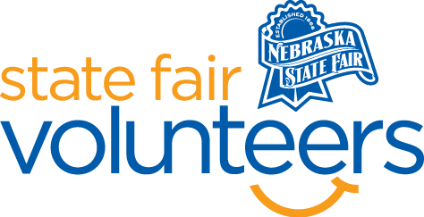
NSF Volunteer Information Sheet

Thank you for offering your time and efforts for the Nebraska State Fair! Your time is very valuable to us, and we appreciate everything that you have to offer to make the Nebraska State Fair a success.

Volunteer Position: Textile Arts

• Check-In:
- Your yellow name badge will be your gate admission into the fair. It is to only be used on days that you are volunteering.
- All volunteers are required to check-in with the volunteer coordinator at Volunteer Headquarters (VHQ) in the Pinnacle Expo Building prior to their shift.
- VHQ assistants will check you in and share the location of where your shift begins.

• Location: 4-H/FFA Fieldhouse

• Responsibilities:
- The most important role of the volunteer will play is that of goodwill ambassador. The most important words they can say are “Hi, welcome to the Nebraska State Fair, we are glad you are here!”.
- Volunteers will be expected to have a smile and helpful attitude at all time while volunteering. They will be getting questions and will do a lot of directing toward various State Fair activities going on that day.
- Textile Arts volunteers will be positioned in the 4-H/FFA Fieldhouse in the Textile Arts display area.
- There will be a notebook that will include a copy of the Textile Arts entry book, a list of exhibitors, and other information. The book will be located at the volunteer table by the south entrance.
- The main responsibility will be to circulate among the display cases to deter visitors from touching/handling exhibits and to share interesting facts about the department. Most of the items will be inside a case. Exhibitors will appreciate seeing that there is visible security in the area where they have exhibits.

• Requirements:
- Indoors
- Lifting Requirements: None
- Sitting with some standing/roving

• Check-Out:
- Volunteers do not need to check out at VHQ as the new system will automatically check you out.

