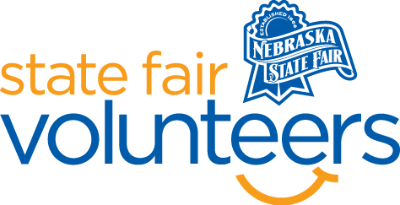
NSF Volunteer Information Sheet

Thank you for offering your time and efforts for the Nebraska State Fair! Your time is very valuable to us, and we appreciate everything that you have to offer to make the Nebraska State Fair a success.

Volunteer Position: State Fair Marathon Route Worker

• Check-In:
- Your yellow name badge will be your gate admission into the fair. It is to only be used on days that you are volunteering.
- All volunteers are required to check-in with the volunteer coordinator at Volunteer Headquarters (VHQ) in the Pinnacle Expo Building prior to their shift.
- VHQ assistants will check you in and share the location of where your shift begins.

• Location:
- Throughout the Marathon Racecourse

• Responsibilities:
- Direct runners at turns throughout the course.
- Give signals to the runners to make sure they stay on course.
- If positioned at an intersection that is blocked for traffic, keep cars off the course and maintain a safe environment for runners.
- Cheer runners on

• Requirements:
- Indoors or Outdoors: Standing with no guarantee of shade.
- Lifting Requirements: No lifting required

• Check-Out:
- Volunteers do not need to check out at VHQ as the new system will automatically check you out.

