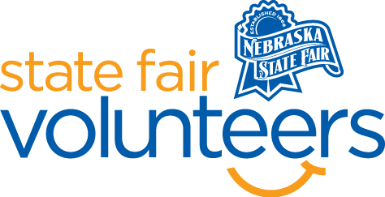
NSF Volunteer Information Sheet

Thank you for offering your time and efforts for the Nebraska State Fair! Your time is very valuable to us, and we appreciate everything that you have to offer to make the Nebraska State Fair a success.

Volunteer Position: EXAMPLE: Signage Prep Work

• Check-In:
- Your yellow name badge will be your gate admission into the fair. It is to only be used on days that you are volunteering.
- All volunteers are required to check-in with the volunteer coordinator at Volunteer Headquarters (VHQ) in the Pinnacle Expo Building prior to their shift.
- VHQ assistants will check you in and share the location of where your shift begins.

• Location:
  - Second floor of the Nebraska Building.
  - Take the elevator to the second floor and ask for Eileen at the front desk
• Responsibilities:
- DO YOUR HOMEWORK! Be familiar with the State Fair gate book: daily schedules, general fair information, and the grounds map (BEFORE your shift).
- Sign Prep: Work with Signage manager.
- Able to hand trim signs with scissors and xacto knife and laminate signs sizes very small to 28” x 44” size
- Prepare signs for delivery; roll, mark and band.
- Help deliver and place signs into springboards on grounds.
- As needed; together with help move springboards.
- Deliver rolled signs to other departments as needed and or pick up rolled signs.
- Prep used signs for storage to reuse.
- There is a possibility there will be days your help is not needed; the Signage Manager will let you know this and send you back to VHQ to be assigned to another position.

• Requirements:
- Indoors or Outdoors: Both
- Lifting Requirements: You will be walkin around the fairgrounds with signs to hang up

• Check-Out:
- Volunteers do not need to check out at VHQ as the new system will automatically check you out.

