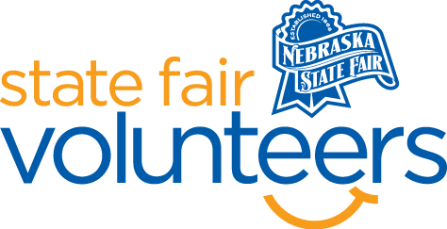
NSF Volunteer Information Sheet

Thank you for offering your time and efforts for the Nebraska State Fair! Your time is very valuable to us, and we appreciate everything that you have to offer to make the Nebraska State Fair a success.

Volunteer Position: Picnic & Table Wiping
• Check-In:
- Your yellow name badge will be your gate admission into the fair. It is to only be used on days that you are volunteering.
- All volunteers are required to check-in with the volunteer coordinator at Volunteer Headquarters (VHQ) in the Pinnacle Expo Building prior to their shift.
- VHQ assistants will check you in and share the location of where your shift begins.

• Location:
  - Throughout the fairgrounds

• Responsibilities:
  - You will first pick up your cleaning supplies at the Cleaning Department Office. They are located through the Fonner Park Administration Office doors and take a left.
  - You are responsible for going around to the all the tents and outdoor eating areas and wiping them off.
  - If you see trash around, please pick it up and throw it away
  - When your shift is completed return cleaning supplies to the Cleaning Department Office

• Requirements:
- Indoors or Outdoors: Outdoors
- Lifting Requirements: No major lifting is required, but you will be walking around

• Check-Out:
- Volunteers do not need to check out at VHQ as the new system will automatically check you out.

