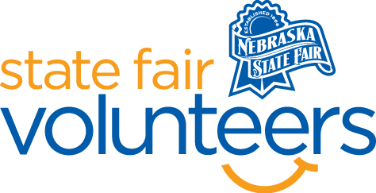
NSF Volunteer Information Sheet

Thank you for offering your time and efforts for the Nebraska State Fair! Your time is very valuable to us, and we appreciate everything that you have to offer to make the Nebraska State Fair a success.
Volunteer Position: Photography Department
• Check-In:
- Your yellow name badge will be your gate admission into the fair. It is to only be used on days that you are volunteering.
- All volunteers are required to check-in with the volunteer coordinator at Volunteer Headquarters (VHQ) in the Pinnacle Expo Building prior to their shift.
- VHQ assistants will check you in and share the location of where your shift begins.

• Location: 4-H/FFA Fieldhouse
• Responsibilities:
- Be familiar with locations of various classes to assist exhibitors and guests in locating specific photographs.
- Monitor and remind guests not to touch the photographs.
- Use exhibitor book to help find photographs.
- Encourage people to vote for people’s choice.
- Replace photographs on walls that come down.
- One volunteer will be stationed at the photography information table the other will be watching the photographs in the hallway.
- Do you homework. Be familiar with the Nebraska State Fair gate book: daily schedules, general fair information, and the grounds map.
- Be prepared to get asked the same questions often. Deliver your answer as if it is the first time you have heard that question with a helpful smile.
- Be read to use a grounds map and landmarks to direct guests to their destination.
- Remain calm, positive, and helpful at all times. Unfortunately, a few guests may see you as an outlet for complaints. Help the guest whenever you can and direct them to a more appropriate outlet when you cannot be of assistance. Nebraska State Fair Administration Office is often the necessary destination so know how to direct complaints there.
- Greet guests in a happy and positive manner and don’t forget to smile.
• Requirements:
- Indoors
- Lifting Requirements: none
- Sitting: Position at the table - over 90% of the time. Position in hallway – 75% of the time

• Check-Out:
- Volunteers do not need to check out at VHQ as the new system will automatically check you out.

