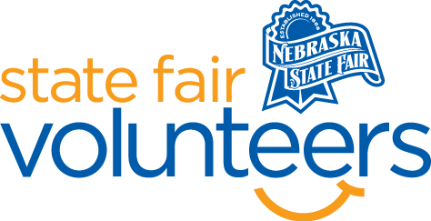
NSF Volunteer Information Sheet

Thank you for offering your time and efforts for the Nebraska State Fair! Your time is very valuable to us, and we appreciate everything that you have to offer to make the Nebraska State Fair a success.

Volunteer Position: Pedal Pull Hall Monitor

• Check-In:
- Your yellow name badge will be your gate admission into the fair. It is to only be used on days that you are volunteering.
- All volunteers are required to check-in with the volunteer coordinator at Volunteer Headquarters (VHQ) in the Pinnacle Expo Building prior to their shift.
- VHQ assistants will check you in and share the location of where your shift begins.

• Location:
- Heartland Events Center

• Responsibilities:
- Sit at the entrances to the back hallway to keep fairgoers out of these areas.
- Direct guests to the restroom and other amenities in the Event Center.

• Requirements:
- Indoors or Outdoors: Indoors, Chair provided.
- Lifting Requirements: No lifting required

• Check-Out:
- Volunteers do not need to check out at VHQ as the new system will automatically check you out.

