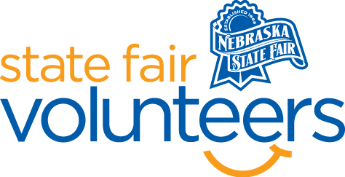
NSF Volunteer Information Sheet

Thank you for offering your time and efforts for the Nebraska State Fair! Your time is very valuable to us, and we appreciate everything that you have to offer to make the Nebraska State Fair a success.

Volunteer Position: Off-Site Shuttle Bus Greeter
*Must be comfortable and willing to use the microphone, interact with bus guests, and provide continuous commentary!

• Check-In:
- Your yellow name badge will be your gate admission into the fair. It is to only be used on days that you are volunteering.
- All volunteers are required to check-in with the volunteer coordinator at Volunteer Headquarters (VHQ) in the Pinnacle Expo Building prior to their shift.
- VHQ assistants will check you in and share the location of where your shift begins.

• Location:
- Riding an off-site shuttle bus

• Responsibilities:
- Welcome all guests as they board the shuttle bus.
- Record / Document the number of passengers at each stop the best you can (clicker should be available, if not, please count or estimate the number of bus riders. At the end of your shift, give the spreadsheet & clicker/counter to the next shuttle bus volunteer. The last shift (of the day) volunteer should turn both into the Zone Supervisor at end of the last shift.
- Loudly and clearly, announce whether it’s a (north or south bus) as well as the location of where guests have just left their vehicle (store name and/or parking row). I.e. “This is the north route, Sams Club, bus. Please remember that information for your return trip.”
  - Know the daily Fair schedule, be ready and willing to highlight the day activities, as well as to make suggestions about attractions and events that are occurring that day. Include some of your personal favorite food, beverage, and merchandise (talk into the bus microphone/PA system).
  - Be prepared to answer questions about the Fair in general.
- Mention State Fair Sponsors and encourage guests to visit these sponsors at the Fair and throughout the year.
- Remind passengers that they will need to return to the bus loading/unloading area to get on the shuttle back to their vehicle. Buses stop running at 10:45 p.m. on non-concert night weekdays and 11:30 p.m. on Concert Nights and Weekends, so they should arrive no later than 20 minutes prior to this time.
- Bid passengers farewell and wish for them to have a FAIRtastic day.

• Requirements:
- Indoors or Outdoors: Air-conditioned bus
- Lifting Requirements: No lifting required but must be able to climb steps onto a charter bus.

• Check-Out:
- Volunteers do not need to check out at VHQ as the new system will automatically check you out.

