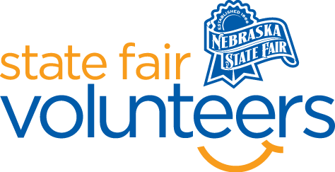
NSF Volunteer Information Sheet

Thank you for offering your time and efforts for the Nebraska State Fair! Your time is very valuable to us, and we appreciate everything that you have to offer to make the Nebraska State Fair a success.

Volunteer Position: Older Nebraskan’s Day

• Check-In:
- Your yellow name badge will be your gate admission into the fair. It is to only be used on days that you are volunteering.
- All volunteers are required to check-in with the volunteer coordinator at Volunteer Headquarters (VHQ) in the Pinnacle Expo Building prior to their shift.
- VHQ assistants will check you in and share the location of where your shift begins.

• Location:
- Outside of Bosselman Conference Center and Heartland Event Center. Trade show hours are 9 a.m. to 2 p.m. (Hours may change)

• Responsibilities:
- This position requires standing, sitting, and lifting.
- 2 volunteers will be greeting vendors as they arrive, checking them in, and showing them to their table. When fair guests arrive, volunteers will greet and hand out complimentary bags. 8:30am – until complimentary bags are gone.
- 2 volunteers will assist the exhibitors with unloading their car, as needed. A cart will be provided. 8am – 9am. 2 volunteers to assist exhibitors move out 1:30pm – 2:30pm.
- Remind exhibitors to move their cars to general parking or to the vendor parking lot as soon as they are finished unloading. Make sure that all cars are moved to parking by 8:30a.m.
- Assist with load-out at the end of the day.
Call for carts from Volunteer Headquarters and Sales team to help exhibitors get equipment to their vehicles. (Keaton: 308-293-6530; Jenny: 308-214-0909)

• Requirements:
- Indoors or Outdoors: Outdoor
- Lifting Requirements: Possibility on the position you are placed in

• Check-Out:
- Volunteers do not need to check out at VHQ as the new system will automatically check you out.

