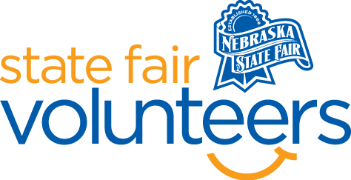
NSF Volunteer Information Sheet

Thank you for offering your time and efforts for the Nebraska State Fair! Your time is very valuable to us, and we appreciate everything that you have to offer to make the Nebraska State Fair a success.

Volunteer Position: Low Sensory Room Monitor

• Check-In:
- Your yellow name badge will be your gate admission into the fair. It is to only be used on days that you are volunteering.
- All volunteers are required to check-in with the volunteer coordinator at Volunteer Headquarters (VHQ) in the Pinnacle Expo Building prior to their shift.
- VHQ assistants will check you in and share the location of where your shift begins.

• Location:
- Bosselman Conference Center Room 5 (located on the South end of the Heartland Events Center)

• Responsibilities:
- Sit outside the Low Sensory room and monitor those entering/leaving the room.
- Tidy the space after the guests leave.
- Ensure that the space is being used for its given purpose: allowing individuals to re-regulate in a high sensory environment. If you feel that individuals in the room are not using the space for this, please ask politely to redirect or leave the space.
- If you have any questions or concerns during your shift, please feel free to contact Olivia Koenig at (612) 756-5483.
• Requirements:
- Indoors or Outdoors: Indoors, a chair will be provided.
- Lifting Requirements: Minimal lifting and tidying of the space are required.

• Check-Out:
- Volunteers do not need to check out at VHQ as the new system will automatically check you out.

