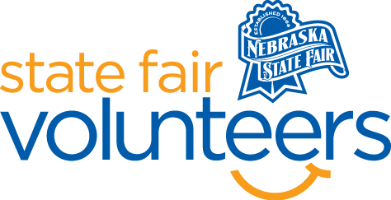
NSF Volunteer Information Sheet

Thank you for offering your time and efforts for the Nebraska State Fair! Your time is very valuable to us, and we appreciate everything that you have to offer to make the Nebraska State Fair a success.

Volunteer Position: Nebraska’s Largest Classroom Check-In and Lunch Program Volunteer

• Check-In:
- Your yellow name badge will be your gate admission into the fair. It is to only be used on days that you are volunteering.
- All volunteers are required to check-in with the volunteer coordinator at Volunteer Headquarters (VHQ) in the Pinnacle Expo Building prior to their shift.
- VHQ assistants will check you in and share the location of where your shift begins.

• Location:
- Check-In: Main Gate and Gate 5A
- Lunch Program: Fonner Park Clubhouse (3rd Floor)

• Responsibilities:
- Assist with check-in. Check-in sheets, a list of schools attending that day, and extra wristbands will be provided.
  - Check-in at the main gate will consist of primarily homeschool groups. Ensure that everyone in the group has either a wristband or gate admission ticket. Have the group leader fill out the check-in sheet.
  - Check-in at gate 5A will consist of larger public/private school groups in buses or vans. Ensure that everyone in the group has either a wristband or gate admission ticket. Have the group leader fill out the check-in sheet.
  - Check-in will be from 8:30 am to 10:15 am. Please be in place by 8:15 am to be prepared for the students’ arrival.
  - Lunches were pre-ordered. No additional lunches can be ordered day-of.
  - Return check-in materials to VHQ after your shift.
- Assist with the lunch program. Lunch will be available from 10:30 am to 1:30 pm.
  - Help move sack lunches from the bus area to the clubhouse. *Those who volunteer for this role must be able to lift 50 lbs. and have completed the Nebraska State Fair’s vehicle training prior.
  - Dropping off sack lunches will be a continuous process during check-in. All lunches must be dropped off by 10:30 am.
  - Volunteers must be stationed at the clubhouse from 10:30 am to 1:30 pm. Volunteers may begin to bring lunch coolers back to the bus area during this time, as schools finish their lunches. All lunch coolers must be returned to the bus area by 2:00 pm.
  - Volunteers may help with directing traffic, greeting school groups, checking wristbands, handing out lunches, and cleaning.
  - Ensure that the space is properly cleaned before leaving.
- If you have any questions or concerns during your shift, please feel free to contact Olivia Koenig at (612) 756-5483.
• Requirements:
- Indoors or Outdoors: both; standing for long periods of time.
- Lifting Requirements: those assisting with moving sack lunches must be able to lift up to 50 lbs.

• Check-Out:
- Volunteers do not need to check out at VHQ as the new system will automatically check you out.

