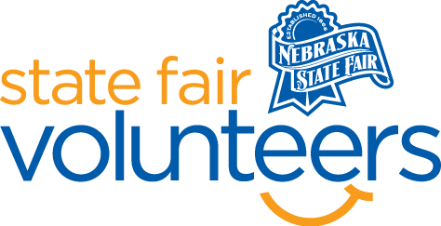
NSF Volunteer Information Sheet

Thank you for offering your time and efforts for the Nebraska State Fair! Your time is very valuable to us, and we appreciate everything that you have to offer to make the Nebraska State Fair a success.

Volunteer Position: Horticulture
• Check-In:
- Your yellow name badge will be your gate admission into the fair. It is to only be used on days that you are volunteering.
- All volunteers are required to check-in with the volunteer coordinator at Volunteer Headquarters (VHQ) in the Pinnacle Expo Building prior to their shift.
- VHQ assistants will check you in and share the location of where your shift begins.

• Location: 4-H/FFA Fieldhouse

• Responsibilities:
- As a whole, the most important role that the volunteers will play is that of goodwill ambassador. The most important words they can say are “Hi, welcome to the Nebraska State Fair, we are glad you are here!”.
- Volunteers will be expected to have a smile and helpful attitude at all times while volunteering. They will be getting questions and will do a lot of directing towards various State Fair activities happening that day.
- Helping exhibitors put flowers on display.
- Help judges with placing ribbons on the cards.

• Requirements:
- Indoors
- Lifting Requirements: Most item are under 5 pounds.
- Will have opportunities to sit but will be standing and helping the judge/exhibitors.

• Check-Out:
- Volunteers do not need to check out at VHQ as the new system will automatically check you out.

