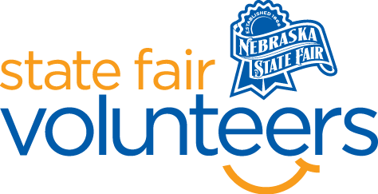
NSF Volunteer Information Sheet

Thank you for offering your time and efforts for the Nebraska State Fair! Your time is very valuable to us, and we appreciate everything that you have to offer to make the Nebraska State Fair a success.

Volunteer Position: Hand Stamper Volunteer

• Check-In:
- Your yellow name badge will be your gate admission into the fair. It is to only be used on days that you are volunteering.
- All volunteers are required to check-in with the volunteer coordinator at Volunteer Headquarters (VHQ) in the Pinnacle Expo Building prior to their shift.
- VHQ assistants will check you in and share the location of where your shift begins.

• Location:
- Two at Main Gate
- One at North Gate

• Responsibilities:
  - Thank guests: Provide visitors with a great ‘last impression’. The most important role that the Stampers will play is that of a “goodwill ambassador.” The most important words they can say are “Thanks for coming to the Fair! We loved having you – will you be coming back?!”
  - Stamp: Stampers are expected to ask the guest(s) if they will be returning. In doing this, it should also be made clear to the guest that a hand stamp is required for re-entry.
  - Thank you: The Nebraska State Fair wants to leave a lasting impression on visitors even after their day has come to an end at the Fair. Stampers will provide one last smile, wave, and “thanks for coming” as guests depart from the grounds.
  - The stamp MUST be returned to gate staff after your shift, if there is no one there to relieve you. There must be someone hand stamping at all times from 10a-9p.

• Requirements:
- Indoors or Outdoors: Outdoors only, shade is not guaranteed, but a chair will be provided.
- Lifting Requirements: No lifting is required.

• Check-Out:
- Volunteers do not need to check out at VHQ as the new system will automatically check you out.

