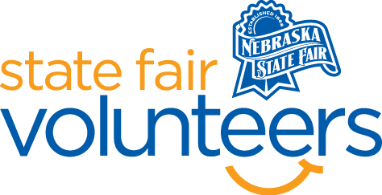
NSF Volunteer Information Sheet

Thank you for offering your time and efforts for the Nebraska State Fair! Your time is very valuable to us, and we appreciate everything that you have to offer to make the Nebraska State Fair a success.

Volunteer Position: High School Rodeo Parking

• Check-In:
- Your yellow name badge will be your gate admission into the fair. It is to only be used on days that you are volunteering.
- All volunteers are required to check-in with the volunteer coordinator at Volunteer Headquarters (VHQ) in the Pinnacle Expo Building prior to their shift.
- VHQ assistants will check you in and share the location of where your shift begins.

• Location: Check-in at the Luebbe Lot Equine Trailer (located in Luebbe Lot)

• Responsibilities:
- Greeting rodeo contestants as they arrive.
- Help guide contestants to parking places.
- Help keep traffic flowing.
- Help keep outside traffic out of flow.

• Requirements:
- Indoors or Outdoors: Outdoors
- Lifting Requirements: None
- This volunteer job will require you to be on your feet most of the time.
- Feel comfortable giving instructions to strangers.
- Be able to deal with a high pressure situation.
- Be comfortable take instructions from the Superintendent.

• Check-Out:
- Volunteers do not need to check out at VHQ as the new system will automatically check you out.

