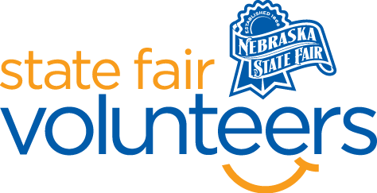
NSF Volunteer Information Sheet

Thank you for offering your time and efforts for the Nebraska State Fair! Your time is very valuable to us, and we appreciate everything that you have to offer to make the Nebraska State Fair a success.

Volunteer Position: Gate Greeter Volunteer

• Check-In:
- Your yellow name badge will be your gate admission into the fair. It is to only be used on days that you are volunteering.
- All volunteers are required to check-in with the volunteer coordinator at Volunteer Headquarters (VHQ) in the Pinnacle Expo Building prior to their shift.
- VHQ assistants will check you in and share the location of where your shift begins.

• Location:
- Two at Main Gate
- One at North Gate

• Responsibilities:
  - Welcome: Provide visitors with the all-important “first impression.” The most important words they can say are “Hi, welcome to the Nebraska State Fair, we are glad you are here!”
  - Information: Greeters will be expected to always have a smile and helpful attitude while “on duty.” They will be getting questions and will do a lot of “directing” toward various State Fair activities going on that day. Gate Greeters should try to gain a good all-around knowledge of the Fairgrounds.
  - On Veterans Day at the Fair, all gate greeters that see military personnel dressed in uniform, please add to your greeting “Thank you for serving” to show our great appreciation for our United States military.
  - Child ID Wrist banding: markers and wristbands will be provided by the Gates staff for you to encourage guests with children to put on an ID band as well as take a current picture in front of the sign-up front. It is very important we push guests to fill one out for every child as this could help in the event someone gets lost.
  - Directing: The biggest duty for this job is to direct Fair guests quickly and accurately through ticket lines. All greeters should be stationed outside the main tent at Main Gate. Volunteers at all gates should be stationed BEHIND the scanning station, handing out programs.
    - Direct guests that already have their tickets to walk on through, direct those that need tickets to the little ticket booth windows that are open.
    - Our goal is to not have guests wait more than a couple of minutes to get through the line and into the Fair.
• Requirements:
- Indoors or Outdoors: Outdoors only. Mostly standing, but chairs will be provided.
- Lifting Requirements: No lifting is required.

• Check-Out:
- Volunteers do not need to check out at VHQ as the new system will automatically check you out.

