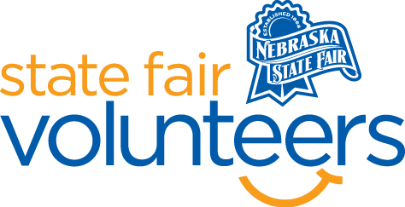
NSF Volunteer Information Sheet

Thank you for offering your time and efforts for the Nebraska State Fair! Your time is very valuable to us, and we appreciate everything that you have to offer to make the Nebraska State Fair a success.

Volunteer Position: Foods Department
• Check-In:
- Your yellow name badge will be your gate admission into the fair. It is to only be used on days that you are volunteering.
- All volunteers are required to check-in with the volunteer coordinator at Volunteer Headquarters (VHQ) in the Pinnacle Expo Building prior to their shift.
- VHQ assistants will check you in and share the location of where your shift begins.

• Location: 4-H/FFA Fieldhouse
• Responsibilities:
- Be prompt and Smile. Greet guests and exhibitors with “I’m glad you are here” or “So good to see you”.
- Volunteers will help check in exhibits.
  - Check the name of the exhibitor with the name that has been submitted either electronically or hard copy. These will be printed out for you.
  - Place entry tag on the exhibit and place exhibit in proper category waiting to be judged.
- At the end of an entry day all exhibits must be checked against the record books so that we are sure we have all the exhibits that have made entry.
- Help judges with placing proper ribbons on the exhibits and recording the exhibit placing on the judging sheets.
- When two or more volunteers are working a shift, either taking entries or helping the judge, we do not discuss entries in any way with anyone. When helping with judging there will be no talking with the judge. This is to ensure fairness.
- When a division is completed entries will be carried to a display case and arranged.
- You will be interacting with fair goers, sharing information, and making sure the entries stay safe.
- Deb Langenheder is the superintendent, please contact her with any questions 308-379-1341 or lang4der@gmail.com
• Requirements:
- Indoors
- Lifting Requirements: no more than 5 pounds.
- This is will a standing and sitting job.
• Check-Out:
- Volunteers do not need to check out at VHQ as the new system will automatically check you out.

