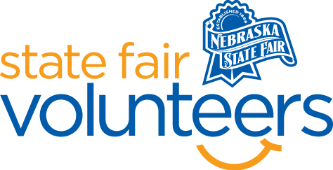
NSF Volunteer Information Sheet

Thank you for offering your time and efforts for the Nebraska State Fair! Your time is very valuable to us, and we appreciate everything that you have to offer to make the Nebraska State Fair a success.

Volunteer Position: First Aid Station Volunteer
• Check-In:
- Your yellow name badge will be your gate admission into the fair. It is to only be used on days that you are volunteering.
- All volunteers are required to check-in with the volunteer coordinator at Volunteer Headquarters (VHQ) in the Pinnacle Expo Building prior to their shift.
- VHQ assistants will check you in and share the location of where your shift begins.

• Location:
  - First Aid Station One – Located on the North side of the Welcome Center
  - First Aid Station Two – Located left the the Fonner Park Administration Office doors (will be labeled FIRST AID)

• Responsibilities:
  - In order to volunteer in this area, you must have some sort of medical background (EX. RN, CNA, EMT). Please email Haley Roush at hroush@statefair.org after you sign up with your name and what your professional background is.
  - Assist those with small injuries, sunburns, and anything else minor that may come in
  - Help nursing mothers
  - If injury is severe you must to radio EMS and let them know your location and the details. They will take care of that individual.
  - Document each individual that comes in with the log provided.
  - More detailed instructions will be provided for this position at Orientation.

• Requirements:
- Indoors or Outdoors: Indoors
- Lifting Requirements: Yes
- MUST HAVE SOME SORT OF MEDICAL BACKGROUND (EX. RN, CNA, EMT)

• Check-Out:
- Volunteers do not need to check out at VHQ as the new system will automatically check you out.

