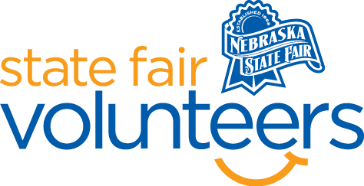
NSF Volunteer Information Sheet

Thank you for offering your time and efforts for the Nebraska State Fair! Your time is very valuable to us, and we appreciate everything that you have to offer to make the Nebraska State Fair a success.

Volunteer Position: Fair Photographer

• Check-In:
- Your yellow name badge will be your gate admission into the fair. It is to only be used on days that you are volunteering.
- All volunteers are required to check-in with the volunteer coordinator at Volunteer Headquarters (VHQ) in the Pinnacle Expo Building prior to their shift.
- VHQ assistants will check you in and share the location of where your shift begins.

• Location: You will be taking photos throughout the fairgrounds

• Responsibilities:
- You will need to provide your own camera to take photos. If you wish to use your cell phone, that is perfectly acceptable. When you are done with your shift, please email all photos over to Haley Roush at hroush@statefair.org
- When taking photos please kindly ask those you are photographing. If they say they don’t want their picture taken, please move on.
- Suggestions of things to photograph: Volunteers working/smiling for a photo, State Fair Staff, guests around the grounds, strolling acts, animals in the barns, anything else you deem acceptable to photograph.
- You will NOT have any access to any of the ticketed events.

• Requirements:
- Indoors or Outdoors: Both, indoors and outdoors
- Lifting Requirements: Requires lots of walking

• Check-Out:
- Volunteers do not need to check out at VHQ as the new system will automatically check you out.

