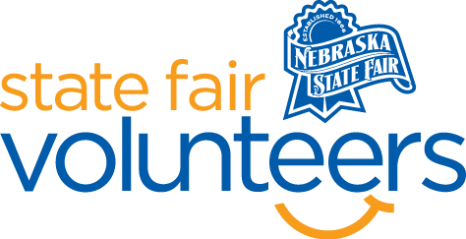
NSF Volunteer Information Sheet

Thank you for offering your time and efforts for the Nebraska State Fair! Your time is very valuable to us, and we appreciate everything that you have to offer to make the Nebraska State Fair a success.

Volunteer Position: Education Department

• Check-In:
- Your yellow name badge will be your gate admission into the fair. It is to only be used on days that you are volunteering.
- All volunteers are required to check-in with the volunteer coordinator at Volunteer Headquarters (VHQ) in the Pinnacle Expo Building prior to their shift.
- VHQ assistants will check you in and share the location of where your shift begins.

• Location: Bosselman Conference Center

• Responsibilities:
Pre-Fair
- Mid-August leading up to the fair need 2-4 people to help with displaying exhibits.
During Fair
- Watch to be sure displays/exhibits are not damaged or taken
- Answer questions guests may have. Ex.) where is the nearest restroom, where are the other open class exhibits displayed?
- Volunteers need to know:
  - Education exhibits do not have to qualify at school/county level to enter the Nebraska State Fair.
  - Education competitions are open to all home, public, or private schools K-12 in Nebraska.
  - Students do not need to be 4-H members to enter the Education Department.
  - Students may be entered by a teacher or parent.
  - There are live and static competitions.
  - Warmth of Veterans items are donated to veterans.
Exhibit Release
- 2 volunteers from 4-6pm Monday, September 2nd to help position tables for exhibit release.
- 2 volunteers from 6-8:30 pm Monday, September 2nd to supervise exhibitors during exhibit release.
- 2 volunteers from 8am to noon Tuesday, September 3rd to supervise exhibit release.
- 2 volunteers from noon until 5pm Tuesday, September 3rd to sort remaining exhibits by school, take down displays, and help pack items for storage.

• Requirements:
- Indoors
- Lifting Requirements: no more than 5 pounds.
- Pre-Fair: will be standing majority of the time hanging posterboard off the pipe and drape and putting exhibits on tables or in display cases.
- During Fair: sitting majority of the time occasionally roving the area.
- Post-Fair: 4pm-6pm Monday, September 2nd will be majority standing time. All other times for release will have the opportunity to sit but will also need to stand and help teachers/families find their exhibits.

• Check-Out:
- Volunteers do not need to check out at VHQ as the new system will automatically check you out.

