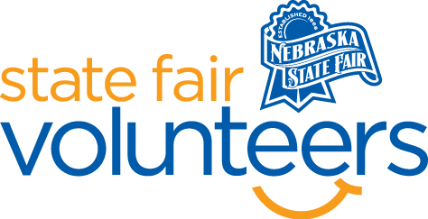
NSF Volunteer Information Sheet

Thank you for offering your time and efforts for the Nebraska State Fair! Your time is very valuable to us, and we appreciate everything that you have to offer to make the Nebraska State Fair a success.

Volunteer Position: Draft Horse Pull

• Check-In:
- Your yellow name badge will be your gate admission into the fair. It is to only be used on days that you are volunteering.
- All volunteers are required to check-in with the volunteer coordinator at Volunteer Headquarters (VHQ) in the Pinnacle Expo Building prior to their shift.
- VHQ assistants will check you in and share the location of where your shift begins.

• Location: Thompson Foods Indoor Arena

• Responsibilities:
- Help with putting cement blocks on the pulling sled and taking blocks off the pulling sled
- Help with stacking cement blocks at the conclusion of the pull

• Requirements:
- Indoors or Outdoors: Outdoors
- Lifting Requirements: Be able to lift at least 50 pounds
- Be comfortable around horses and machinery.
- Be comfortable taking instructions from the Superintendent.

• Check-Out:
- Volunteers do not need to check out at VHQ as the new system will automatically check you out.

