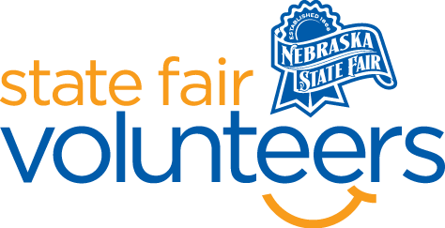
NSF Volunteer Information Sheet

Thank you for offering your time and efforts for the Nebraska State Fair! Your time is very valuable to us, and we appreciate everything that you have to offer to make the Nebraska State Fair a success.

Volunteer Position: Barn Greeter

• Check-In:
- Your yellow name badge will be your gate admission into the fair. It is to only be used on days that you are volunteering.
- All volunteers are required to check-in with the volunteer coordinator at Volunteer Headquarters (VHQ) in the Pinnacle Expo Building prior to their shift.
- VHQ assistants will check you in and share the location of where your shift begins.

• Location:
    - Tom Dinsdale Cattle Barn
    - Sheep Barn

• Responsibilities:
- DO YOUR HOMEWORK! Be familiar with the State Fair gate book which will be distributed approximately a week before the fair: daily schedules, general fair information, and the grounds map (BEFORE your shift).
- GREET GUESTS IN A HAPPY AND POSITIVE MANNER. Smile, offer a warm welcome as guests enter the barn or arena: “Hi, welcome to ____________!
- BE PREPARED TO GET THE SAME QUESTION OFTEN. Deliver your answer as if it is the first time you heard the question and with a helpful smile every time! Be aware of events going on in the facility during your volunteer shift.
- BE READY TO USE A GROUNDS MAP. Help direct guests to their destination!
  - REMAIN CALM, POSITIVE, AND HELPFUL AT ALL TIMES. Unfortunately, a few guests may see you as an outlet for complaints. Help the guests whenever you can and direct them to a more appropriate outlet when you cannot be of assistance. The State Fair Administration Office is often a necessary destination. Know how to direct complaints to this Office.

• Requirements:
- Indoors or Outdoors: Outdoors at the entrance of barns, chair will be provided.
- Lifting Requirements: No lifting is required.

• Check-Out:
- Volunteers do not need to check out at VHQ as the new system will automatically check you out.

