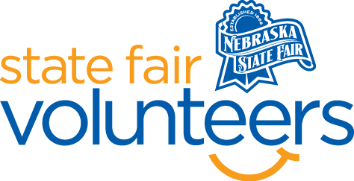
NSF Volunteer Information Sheet

Thank you for offering your time and efforts for the Nebraska State Fair! Your time is very valuable to us, and we appreciate everything that you have to offer to make the Nebraska State Fair a success.

Volunteer Position: Avenue of Breeds Helper

• Check-In:
- Your yellow name badge will be your gate admission into the fair. It is to only be used on days that you are volunteering.
- All volunteers are required to check-in with the volunteer coordinator at Volunteer Headquarters (VHQ) in the Pinnacle Expo Building prior to their shift.
- VHQ assistants will check you in and share the location of where your shift begins.

• Location: Avenue of Breeds – Located in the Grand District

• Responsibilities:
- AM Shift
- Help with getting cattle back into their respective pens.
- Assist with exercising smaller animals, as needed.
- Help with feeding and watering livestock.
- Help with cleaning up night pens.
    - PM Shift
- Help with feeding and watering livestock.
- Help with turning cattle out into their nights.
- Help with cleaning up pens.
- Assist with exercising small animals, as needed.
- Help with tidying up the Avenue of Breeds.

• Requirements:
- Indoors or Outdoors: Outdoors
- Lifting Requirements: Be able to lift 50 pounds
- You will need to have livestock handling experience and knowledge of livestock.
- Be comfortable taking instructions from the Superintendent.

• Check-Out:
- Volunteers do not need to check out at VHQ as the new system will automatically check you out.

