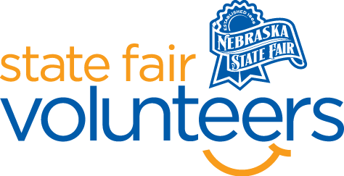
NSF Volunteer Information Sheet

Thank you for offering your time and efforts for the Nebraska State Fair! Your time is very valuable to us, and we appreciate everything that you have to offer to make the Nebraska State Fair a success.

Volunteer Position: AgTivity Acres Volunteer

• Check-In:
- Your yellow name badge will be your gate admission into the fair. It is to only be used on days that you are volunteering.
- All volunteers are required to check-in with the volunteer coordinator at Volunteer Headquarters (VHQ) in the Pinnacle Expo Building prior to their shift.
- VHQ assistants will check you in and share the location of where your shift begins.

• Location:
- Family Fun Zone

• Responsibilities:
- You may find the AgTivity Acres binder of instructions in the Grocery Store (the check-out area of the barn).
- Assist with prepping the space for the day (see binder for instructions).
- Monitor the various activity spaces:
    - Corn Sandbox: a few large corn sandboxes will provide an area for young kids to play in with toy tractors, shovels, etc.
    - Farmers Market: a market, located in the blue and white striped tent, will have stations with toys for kids to play with.
    - Grocery Store: an interactive grocery store will teach kids about what types of food are raised on farms and then sold in store.
  - Keep the AgTivity Acres area organized and be available to explain to parents the different activities the kids can enjoy in this free zone.
  - Assist with organizing the AgTivity Acres at the end of the day. Place all loose items from the area in the grocery store on last shift for next day volunteers to set up.
• Requirements:
- Indoors or Outdoors: Outdoors, combination of sitting and standing.
- Lifting Requirements: Under 5 lbs.

• Check-Out:
- Volunteers do not need to check out at VHQ as the new system will automatically check you out.

